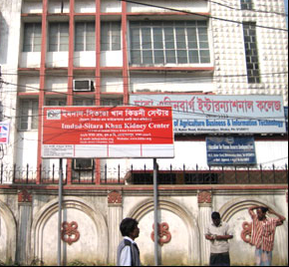
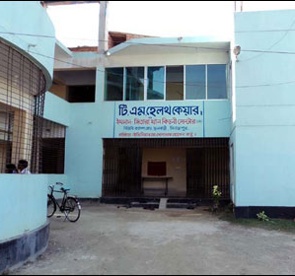
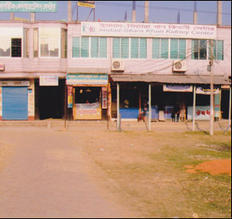
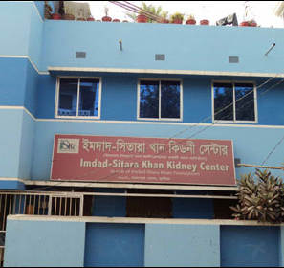
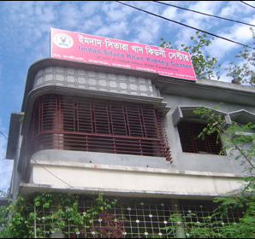
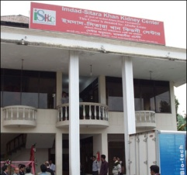
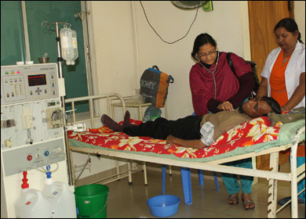




Fee:
$45/person
$160/family of four
BUT THIS IS NOT ENOUGH

* Dhaka * Dinajpur * Bogra *

Since 2006, ISK foundation established 6 kidney dialysis centers
in six Bangladeshi cities

These centers treat Bangladeshis who cannot afford costly kidney disease treatment elsewhere

In 2006, only 70 dialyses
were carried out
In 2012 about 17000 dialyses were provided to the destitute.
Come to the fundraising* dinner for
“SF BayArea Center for Renal Care in Dhaka”
Paradise Palace Ballroom
4100 Peralta Blvd
Fremont, CA 94536
Saturday, October 26 at 6:00pm

Guest Speakers:

Dr. Steven Guest,

a leading US Nephrologist
Performance by
Hyder Hossain
Visit iskkc.org for more information. *Your donation is tax deductible. Payable to “SBF”
* Kushtia * Rajshahi * Moulvibazar *

Six Existing Dialysis Centers

