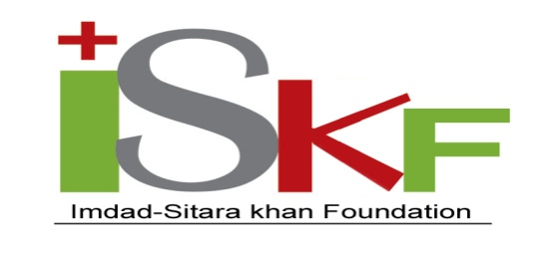
Workshop cum Training on “Haemodialysis, Environmental Hygiene, Safety, Financial and Operational Management of ISK Kidney Centers (ISKKC)”
Session Topics |  | Executing Presenter | Time Frame
Morning Session
Reporting and Registration |  |  | 8.45 - 9.00
Recitation from HolyQuran,Welcome address |  | Md. Sharifur Rahman | 9.00 -0.15
Introducing Participants and  their feedback |  |  | 9.15- 9.30
Skype with Managing Director |  | Dr. AHM Kamal | 9.30-10.00
Introduction to ISKF |  | Air Cadre M. Golam Tawhid | 10.00-10.30
Session 1:  - HD Machine-Technical Aspects and complications |  | Dr. ABM Rafiuddin | 10.30-11.00
Session 2:  - Maintenance of vascular access  - Nutrition of HD patients |  | Dr. Md. Latif | 11.00-11.45
Session 3: Discussion with Patients’ Attendants |  |  | 11.45 -12.00
Tea Break
Session 4:  - Long term complication of HD patients  - Infection control protocol of HD patients and Staffs |  | Dr. kazi Shahnoor Alam | 12.15 – 13.00
Prayer and lunch |  |  | 13.00 – 14.00
Afternoon Session
Session 5:  - Environmental Hygiene & Safety  - Patient Care (Medical History & Record Form)  - Patient Education |  | Dr.Kazi Shahnoor  Dr. Mahmudur Rahman | 14.00 – 15.00
Session 6:  Financial Management  - Financial Report  - Yearly Budget  - Revenue and Donation collection Target  - Service policy |  | Mr.S.H. Zulfiqar Rahman | 15.00 – 16.00
Tea break
Session 7:  Administrative Management  - Daily consultation with on-site administration  - Employee evaluation and corrective action forms, staffing ratio,  - Annual salary review, surveys and recommendation for change,  - Compilation of statistical information  - Data on Weekly dialysis XL sheet,  - Patient Information XL sheet, Resolution of employee disputes,  - Resolution of landlord/tenant issue  Operational Management  - Assure patient satisfaction (Service of excellence)  - Collect patient clinical outcome data on monthly basis,  - Maintain purchase stock and use register of dialysate, fluid, medicine etc.,  - Maintain machinery/equipment purchase and maintenance register,  - Maintain Log register on R.O machine, generator, monthly electricity consumption,  - Maintain Asset register/ Asset audit  - Emergency decision  - Review patient education  - Review safety issue  - Review hygiene issue  - Publicity |  | Md.Sharifur Rahman | 16.00 – 17.00
Session 8: IT |  | Mr. Mrinal Halder | 17.00 -17.30
Session 9: Quiz |  |  | 17.30
Session 10: Thanks giving, photo session and closing

